**Assignment 6**

**Presented by: Qi (daniel) ZHENG G44426724, Sizhe WU G26890251, Ruibo WANG G24256043, Yingyu LIN G48092483, Xinyue ZHAO G27620695**

**Question 1 (a):**

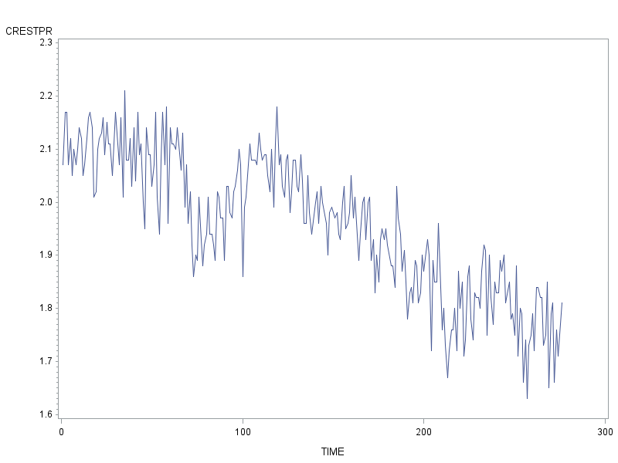

| **Autocorrelations** | | | | |
| --- | --- | --- | --- | --- |
| **Lag** | **Covariance** | **Correlation** | -1 9 8 7 6 5 4 3 2 1 0 1 2 3 4 5 6 7 8 9 1 | **Std Error** |
| **0** | 0.016930 | 1.00000 | |                    |********************| | 0 |
| **1** | 0.014077 | 0.83145 | |                  . |*****************   | | 0.060193 |
| **2** | 0.013676 | 0.80779 | |                .   |****************    | | 0.092912 |
| **3** | 0.013356 | 0.78888 | |               .    |****************    | | 0.115590 |
| **4** | 0.013039 | 0.77014 | |               .    |***************     | | 0.133682 |
| **5** | 0.013084 | 0.77281 | |              .     |***************     | | 0.148892 |
| **6** | 0.012651 | 0.74723 | |             .      |***************     | | 0.162777 |
| **7** | 0.012610 | 0.74480 | |             .      |***************     | | 0.174764 |
| **8** | 0.012271 | 0.72481 | |             .      |**************      | | 0.185909 |
| **9** | 0.012341 | 0.72896 | |            .       |***************     | | 0.195880 |
| **10** | 0.011786 | 0.69613 | |            .       |**************      | | 0.205474 |
| **11** | 0.011544 | 0.68187 | |           .        |**************      | | 0.213849 |
| **12** | 0.011470 | 0.67747 | |           .        |**************      | | 0.221586 |
| **13** | 0.011155 | 0.65891 | |           .        |*************       | | 0.228968 |
| **14** | 0.011021 | 0.65094 | |           .        |*************       | | 0.235738 |
| **15** | 0.010876 | 0.64238 | |          .         |*************       | | 0.242163 |
| **16** | 0.010653 | 0.62923 | |          .         |*************       | | 0.248260 |
| **17** | 0.010626 | 0.62764 | |          .         |*************       | | 0.253973 |
| **18** | 0.010240 | 0.60483 | |          .         |************        | | 0.259532 |
| **19** | 0.0099656 | 0.58863 | |         .          |************        | | 0.264589 |
| **20** | 0.010142 | 0.59903 | |         .          |************        | | 0.269292 |
| **21** | 0.0094275 | 0.55684 | |         .          |***********         | | 0.274078 |
| **22** | 0.0094375 | 0.55743 | |         .          |***********         | | 0.278147 |
| **23** | 0.0092212 | 0.54466 | |         .          |***********         | | 0.282165 |
| **24** | 0.0086943 | 0.51354 | |         .          |**********.         | | 0.285949 |

By observing the plot of time series and the autocorrelation function, we demonstrate that the autocorrelation series is gradually decaying to zero, and the autocorrelation is not chopped off until the end of the series. From the plot of time series, we observe that the series is presenting in a downward trend across the time, which means it’s not behaving in a stochastic pattern. Therefore, this type of pattern and behaviour is expected if the series is a non-stationary time series.

(b).

Table 2.1 ACF of the differenced series

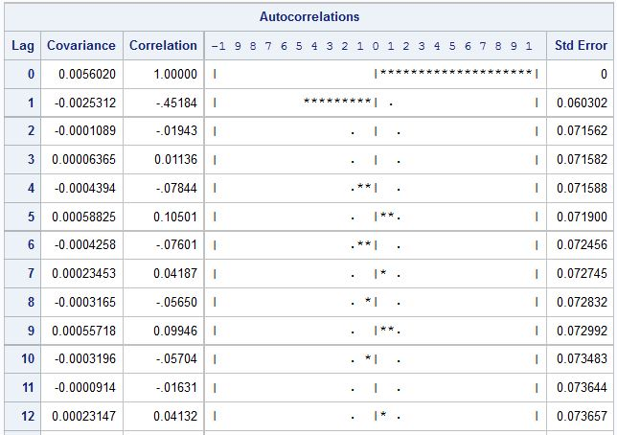

According to Table 2.1, ACF of the first difference of the original time series chops off at lag 1, and reduces to insignificant boundaries afterwards. Therefore, the autocorrelation of the differenced series is rather a function of lag than time, and we can conclude that the series is weakly stationary.

Plot of the differenced series (Figure 1.2) suggests that the series does not have a meaningful trend, and that the series moves quite stochastically. These observations are consistent with its weak stationarity.

Figure 2.1 Plot of the differenced series

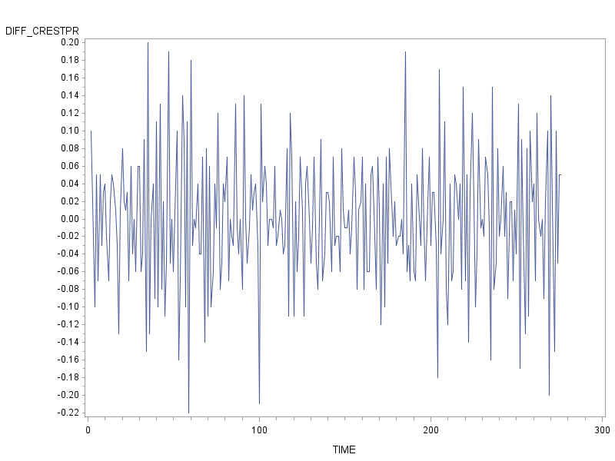

According to Table 2.2, PACF of the differenced series seems to decay quickly, but falls into the insignificant boundaries at lag 5; as a result, the decaying pattern is not convincing and we need to examine the IACF (Table 2.3). On Table 2.3, IACF shows a typical exponential decaying pattern, which confirms that the first-order difference of CRESTPR series can be modeled by an MA process. Also, because the corresponding ACF chops off at lag 1, it would be appropriate to model the series assuming an MA(1) process.

Table 2.2 PACF of the differenced series

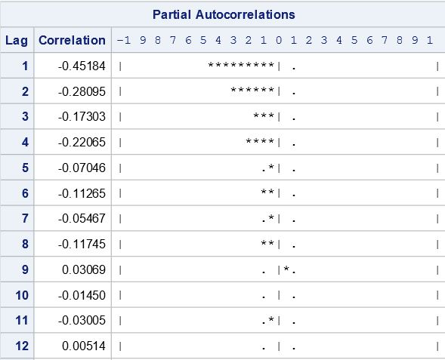

Table 2.3 IACF of the differenced series

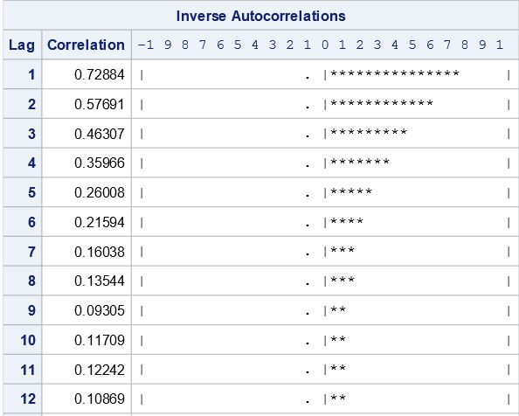

(c).

Two attempts to model the first-order difference were made. The first is a normal MA(1) model, giving the result: $Y+0.0013008=(1-0.76514B)ε_{t}$. However, P-value of the constant (MU in the table) is 0.1385 > 0.05, which is not significant; therefore, we had to accept the null hypothesis that constant equals zero, and model again with ‘*noconstant*’ option.

According to Table 3.1, P-value of the coefficient is smaller than 0.0001, and also smaller than significance level of 9.95; therefore, we could reject the null hypothesis that coefficient θ1 is insignificant, and conclude that the coefficient θ1 is statistically different than zero.

Table 3.1 Model output of the MA(1) model, constant constrained zero.

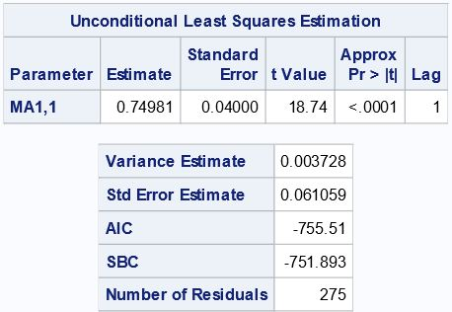

According to Table 3.2, P-value of the χ2-tests at all lags are greater than 0.05; therefore, we can accept the null hypothesis that residual autocorrelation at all lags are statistically equal to zero, and we can conclude that the residual term is white noise on a statistical basis because of its constant mean and constant variance.

Table 3.2 Residual check of the MA(1) model, constant constrained zero.

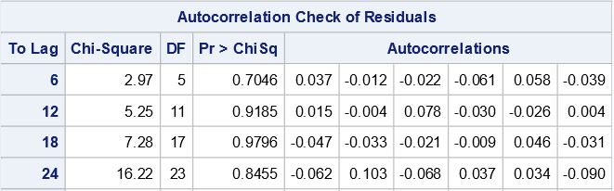

Although variance estimate increases slightly from 0.003714 to 0.003728, the second model is a better model, because it eliminates insignificant constant term while still having a significant θ1 coefficient and a statistically white-noise residual term.

The estimated model can be expressed in the following form:

$$Y_{t}-Y_{t-1}=\left(1-0.74981∙B\right)ε_{t}$$

(d)

| **Autocorrelation Check of Residuals** | | | | | | | | | |
| --- | --- | --- | --- | --- | --- | --- | --- | --- | --- |
| **To Lag** | **Chi-Square** | **DF** | **Pr > ChiSq** | **Autocorrelations** | | | | | |
| **6** | 29.66 | 5 | <.0001 | -0.126 | -0.282 | -0.039 | -0.053 | 0.074 | -0.033 |
| **12** | 32.77 | 11 | 0.0006 | -0.014 | -0.002 | 0.084 | -0.038 | -0.032 | 0.034 |
| **18** | 35.81 | 17 | 0.0049 | -0.029 | -0.022 | -0.015 | 0.003 | 0.077 | -0.052 |
| **24** | 48.89 | 23 | 0.0013 | -0.065 | 0.122 | -0.086 | 0.036 | 0.056 | -0.112 |
| **30** | 51.38 | 29 | 0.0064 | 0.004 | 0.045 | 0.047 | -0.048 | -0.036 | -0.016 |
| **36** | 57.43 | 35 | 0.0098 | 0.043 | -0.017 | -0.059 | 0.099 | -0.010 | -0.061 |
| **42** | 59.17 | 41 | 0.0329 | 0.009 | -0.039 | 0.046 | 0.008 | 0.039 | 0.004 |
| **48** | 62.46 | 47 | 0.0649 | -0.040 | -0.038 | 0.006 | 0.053 | 0.048 | -0.043 |

**Hypothesis testing:**

H0: residual series {εt} is not autocorrelated to the indicated lag, that is lag1= lag2 = lag3=……=0.

Ha: at least one lag is different than 0.

According to the table of autocorrelation check for residual, we rejected every single null hypothesis from lag 6 to lag 42, and concluded that in this AR series at least one autocorrelation of lag is differ than zero; therefore, the residuals of the AR process is not a white noise term. Hence, compare with the MA (1) process, modelling with AR process is not an appropriate way for the first difference of CRESTPR series, mainly because the residual term of the MA process is a white noise.

**Part II:**

(a)

If we were to justify the use of an almost perfect MA(1) modelling, we would have to observe: (1). autocorrelation function is chopped off at lag 1 which indicates the appropriate order of the MA process, and (2). the inverse autocorrelation function decays exponentially in the same manner as its partial autocorrelation function.

(b)

Transformed form of the MA(1) process:

${\dot{Y}}_{t}=(1-θ_{1}B)∙ε_{t}$, that is,

$Y_{t}=24.97770+(1-0.80214B)∙ε_{t}$

(c)

We can conclude that residual εt is statistically a white noise term.

**Hypothesis testing for white noise:**

H0: Residual series {εt} is unautocorrelated to the indicated lag, that is ρ1= ρ2 = ρ3=…=0.

Ha: At least one lag is different than 0

By observing the table of Autocorrelation Check for Residuals, we retain the null hypothesis at 95% confidence level based on P-value of lag 6, lag 12, lag 18, and lag 24, are all greater than 0.05, and we conclude that autocorrelation of {εt} at all lags are statistically equal to zero. Consequently, we can conclude that residual εt is a white noise term on a basis of its constant mean, constant variance, and non-autocorrelation throughout lag 1 to lag 24.

(d)For a theoretical MA(1) model,

$$Y_{t}=μ+\left(1-θ_{1}B\right)ε_{t} \\ ⟹\hat{Y_{t}}\left(2\right)=μ+\hat{ε_{t+2}}-θ_{1}∙\hat{ε_{t+1}}$$

{εt} is white noise with zero mean, therefore $\hat{ε_{t+2}}=\hat{ε_{t+1}}=0$.

$$⟹\hat{Y_{t}}\left(2\right)=μ$$

Thus, two-step ahead forecast for Y should be equal to mean.

(e).

In MA(1) process,

$$Y_{t}=μ+ϵ_{t}-θ_{1}ϵ_{t-1} \\ ⟹Var\left(\dot{Y_{t}}\right)=Var\left(ϵ_{t}\right)+{θ_{1}}^{2}Var\left(ϵ_{t-1}\right) \\ {⟹γ}_{0}={σ_{ε}}^{2}(1+θ^{2})$$

Also, $γ_{1}=Cov\left(Y_{t},Y_{t-1}\right)=-θ_{1}∙Cov\left(ε_{t-1},ε_{t-1}\right)=-θ_{1}{σ_{ε}}^{2}$

Therefore,

$$ρ_{1}=\frac{γ_{1}}{γ_{0}}=\frac{-θ_{1}{σ_{ϵ}}^{2}}{{σ_{ϵ}}^{2}\left(1+{θ_{1}}^{2}\right)}=\frac{-θ_{1}}{1+{θ_{1}}^{2}}=\frac{-0.80214}{1+{0.80214}^{2}}=-0.48809$$

(f).

$PACF(1)=ρ_{1}=-0.48809$

Since for any stationary process $PACF\left(2\right)=\frac{ρ_{2}-{ρ_{1}}^{2}}{1-{ρ_{1}}^{2}}$,

And $ρ_{k}=0, ∀ k≥2$ for an MA(1) process,

Therefore, $PACF\left(2\right)=\frac{{-ρ_{1}}^{2}}{1-{ρ_{1}}^{2}}=\frac{{-(-0.48809)}^{2}}{1-(-{0.48809)}^{2}}=-0.31274$

(g)

For an AR(2) process, the Yule-Walker equation is:

$$\left\{\begin{aligned}ρ_{1}=ϕ_{1}ρ_{0}+ϕ_{2}ρ_{1}=ϕ_{1}+ϕ_{2}ρ_{1} \\ ρ_{2}=ϕ_{1}ρ_{1}+ϕ_{2}ρ_{0}=ϕ_{1}ρ_{1}+ϕ_{2}\end{aligned}\right.$$

For the MA(1) process discussed here, we have ρ0 = 1 and ρ2 = 0, therefore we obtain:

$$\left\{\begin{aligned}ϕ_{1}=\frac{ρ_{1}-ρ_{1}ρ_{2}}{1-{ρ_{1}}^{2}}=-0.64073 \\ ϕ_{2}=\frac{ρ_{2}-{ρ_{1}}^{2}}{1-{ρ_{1}}^{2}}=PACF\left(2\right)=-0.31274\end{aligned}\right.$$